EXPERIMENT 5: - Create a simple cloud software application for Mark Sheet Processing System using any Cloud Service Provider to demonstrate SaaS include the necessary fields such as name of the student, Reg no of the student, Subjects, Marks, Average, percentage, rank, overall performance etc.

Step 1: - Go to ZOHO.com

Step 2: - Create an account and log into the account

Step 3: - Create an application for the respective requirement

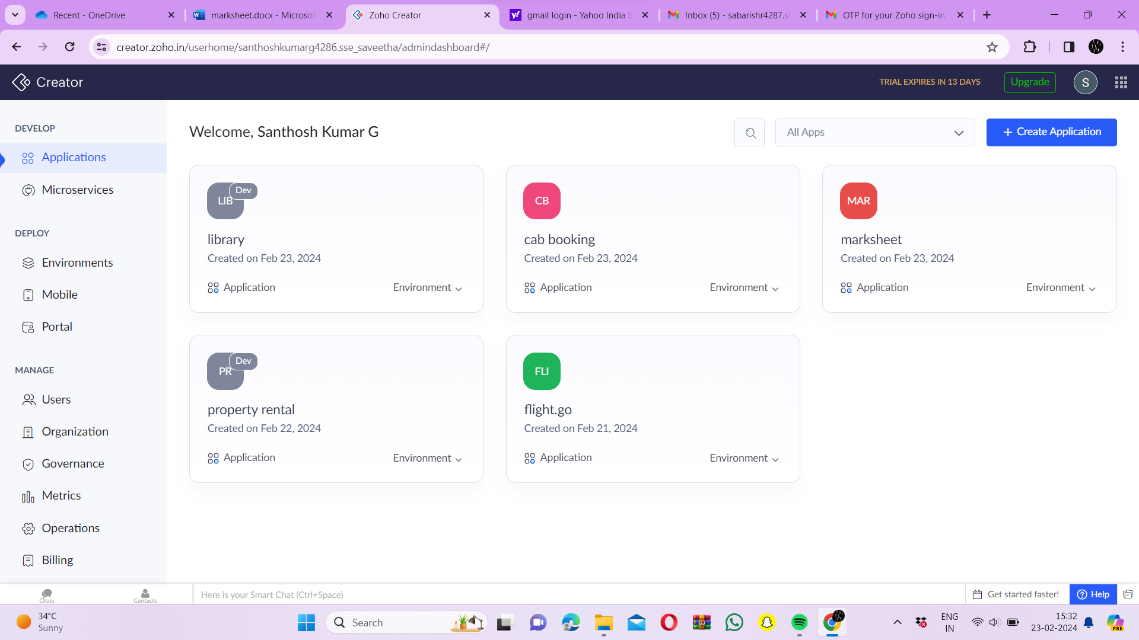

Step 4: - Create a form for student details

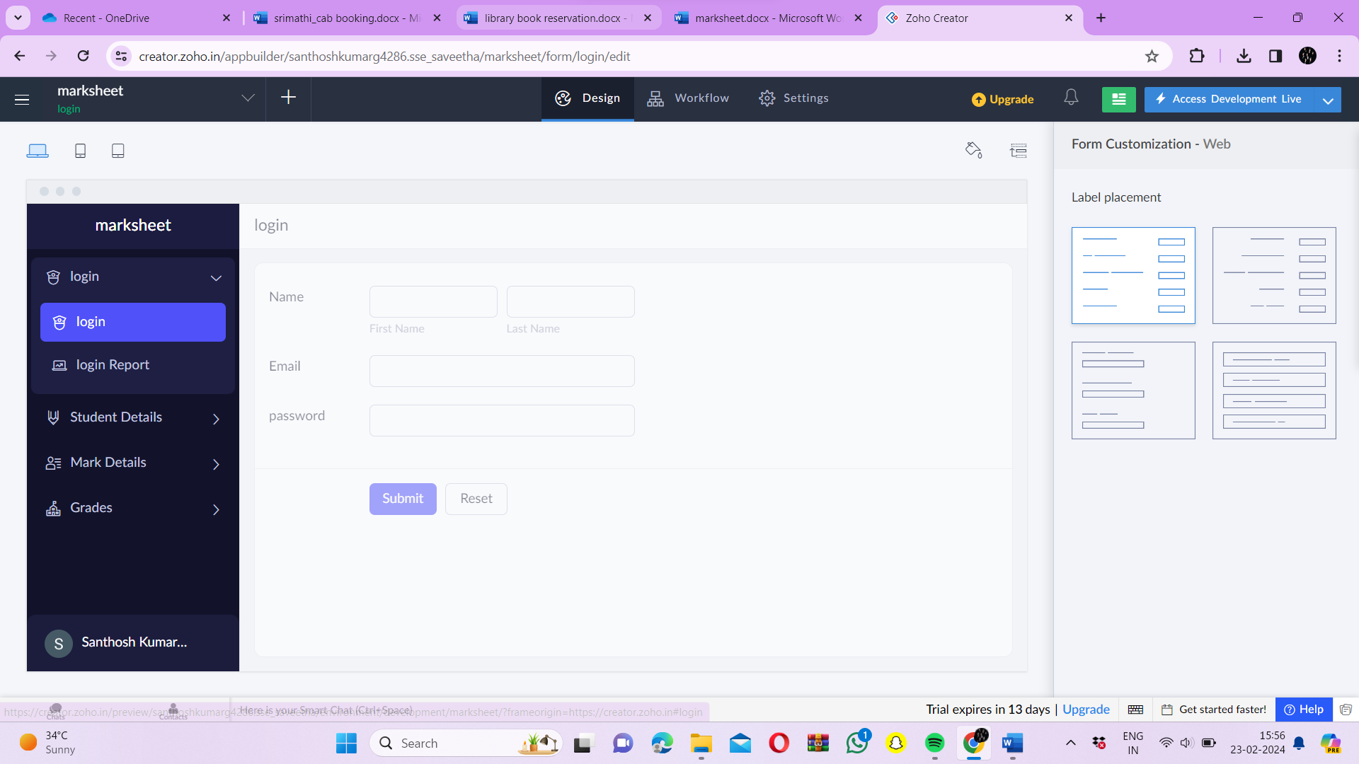

Step 5: - Create a form for subject details

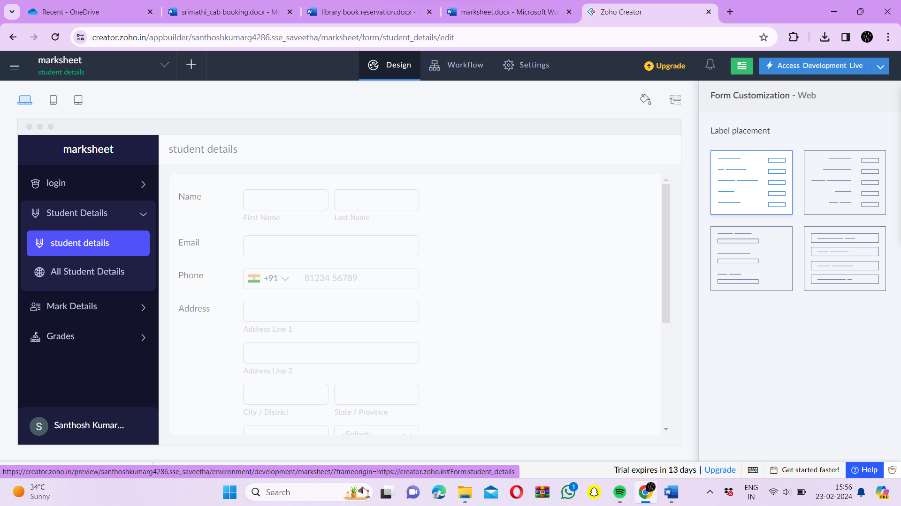

Step 6: - Create a form to enter the marks of the respective subjects

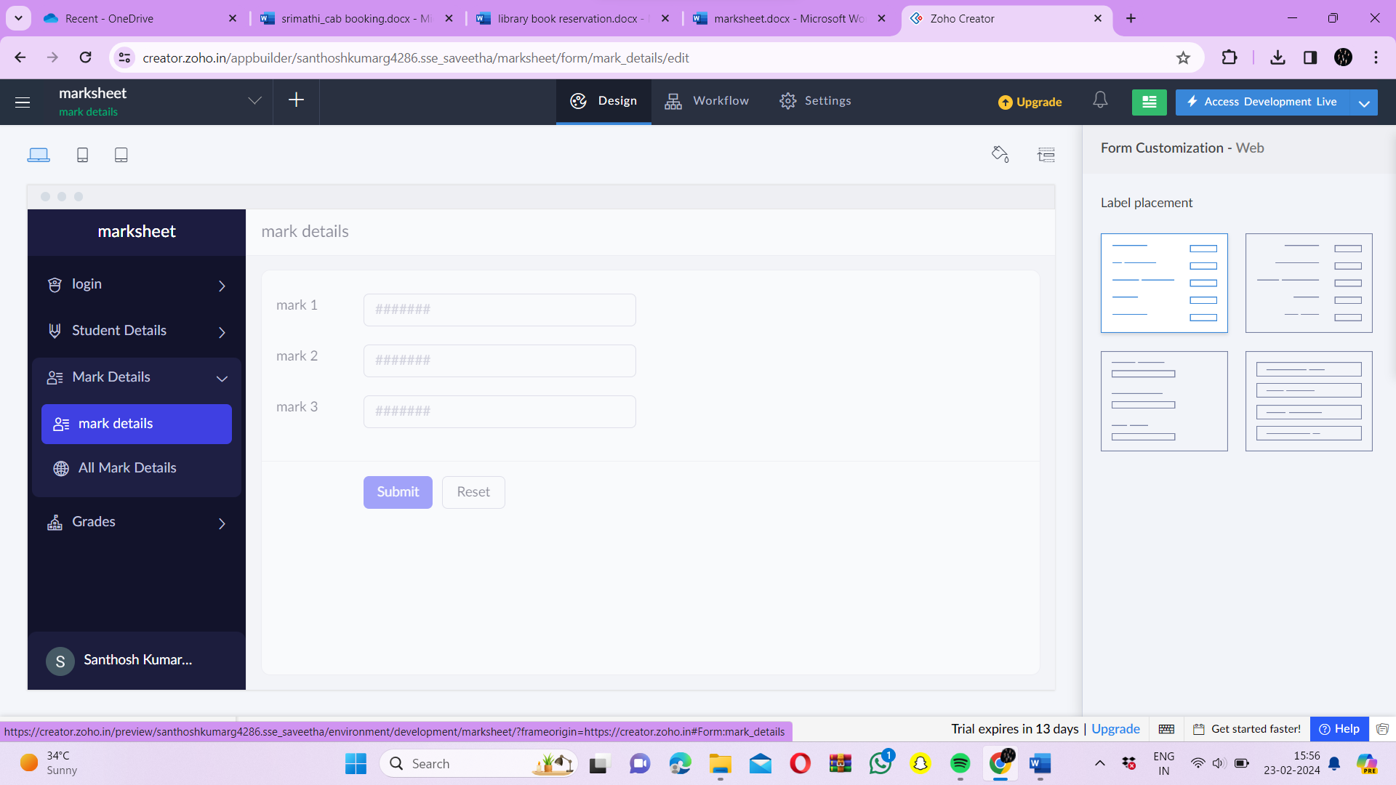

Step 7: - Create a form to enter the grade and performance of the student

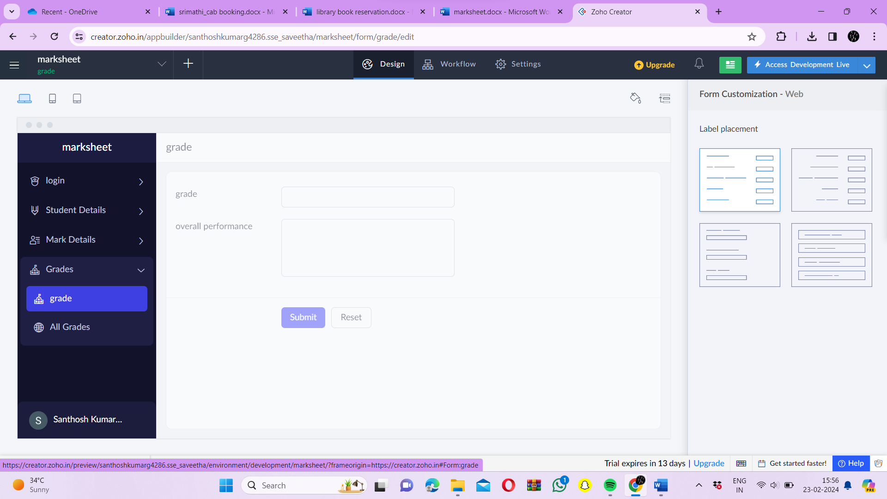

Step 8: - Click the Access development live to view the output

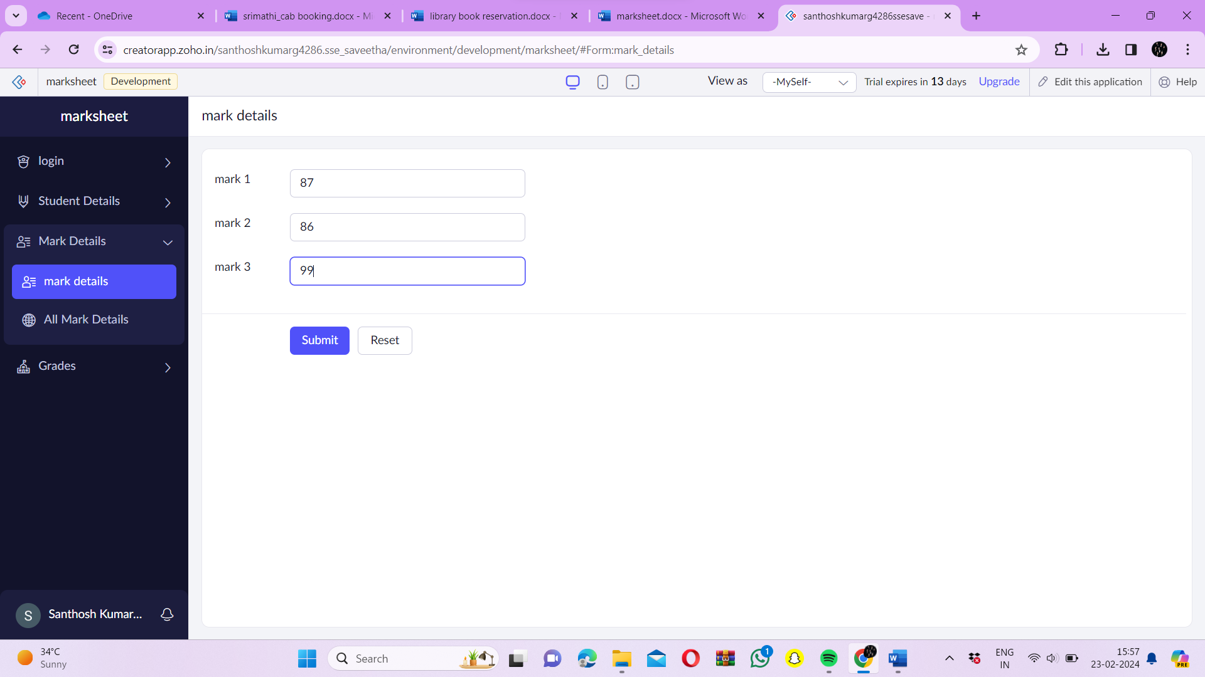

Step 9: - Click the report to view the added data’s

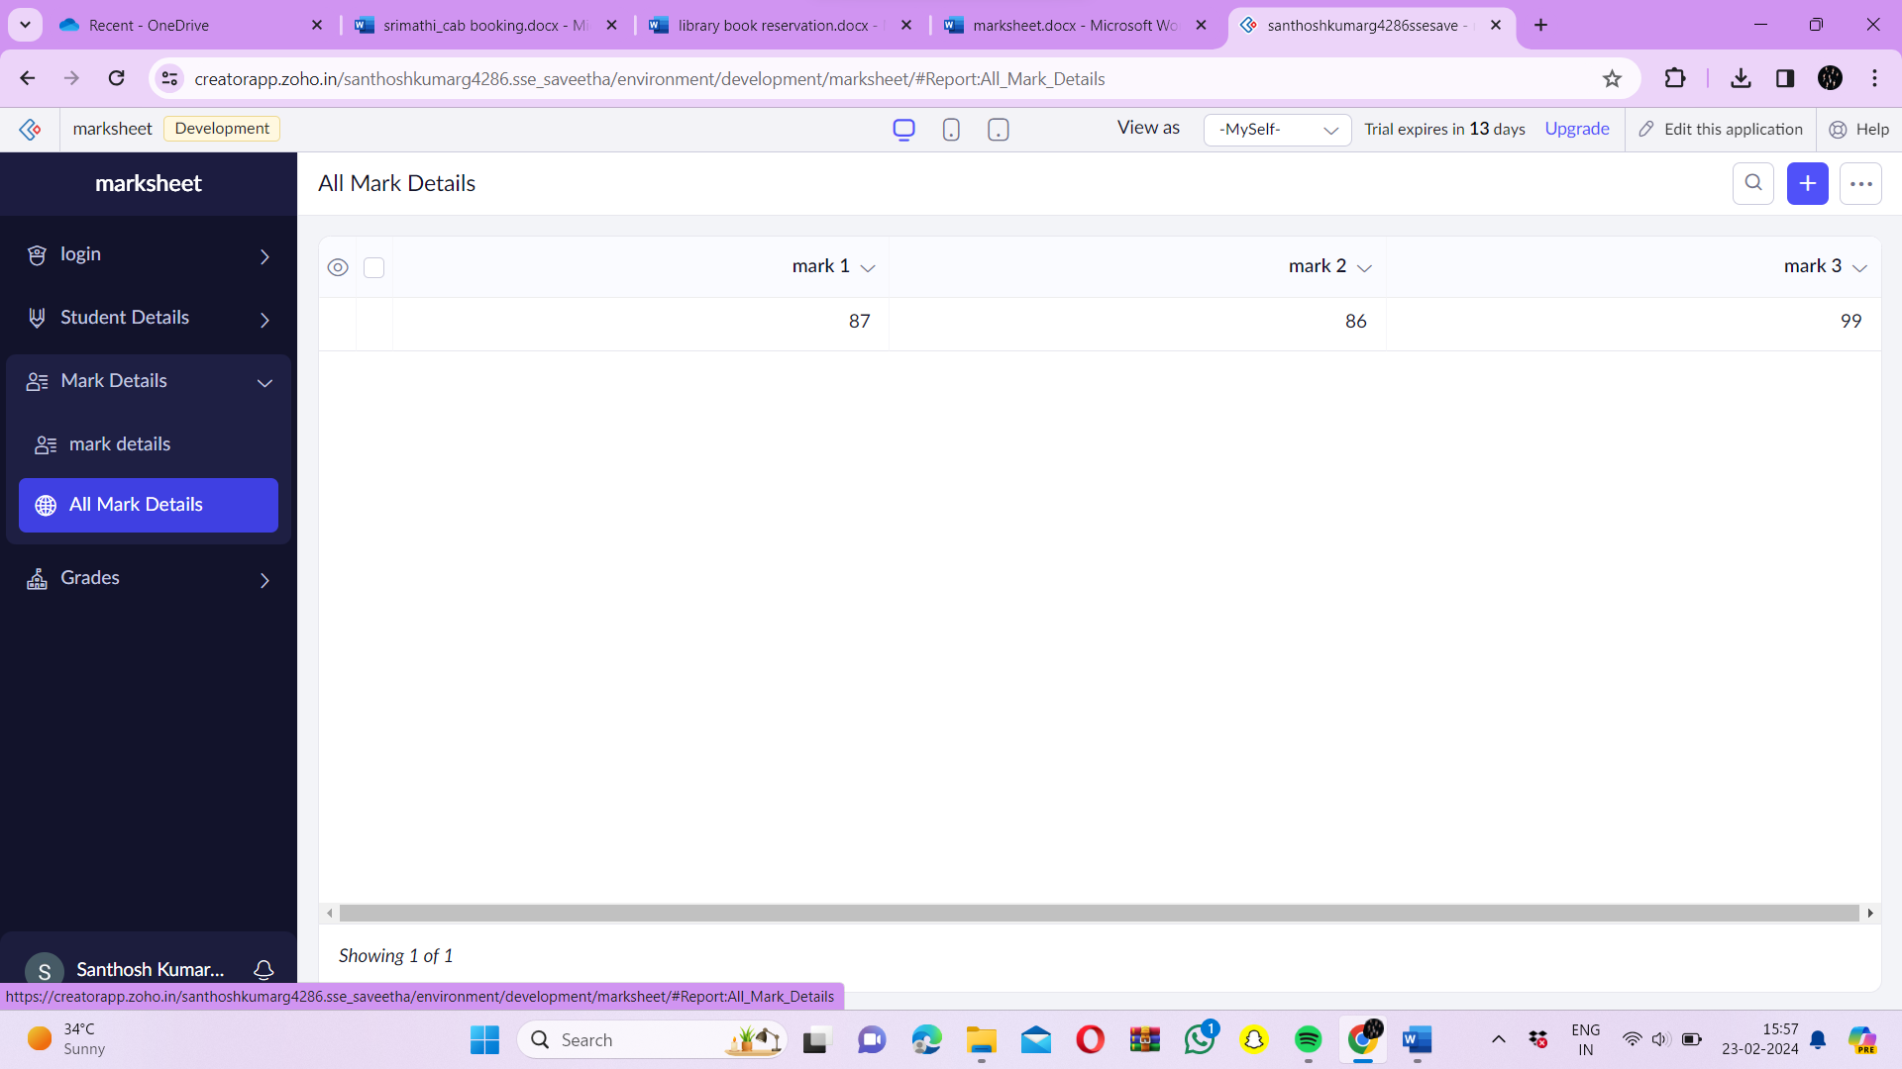

Step 10: - Click the mobile icon to view the output in mobile format

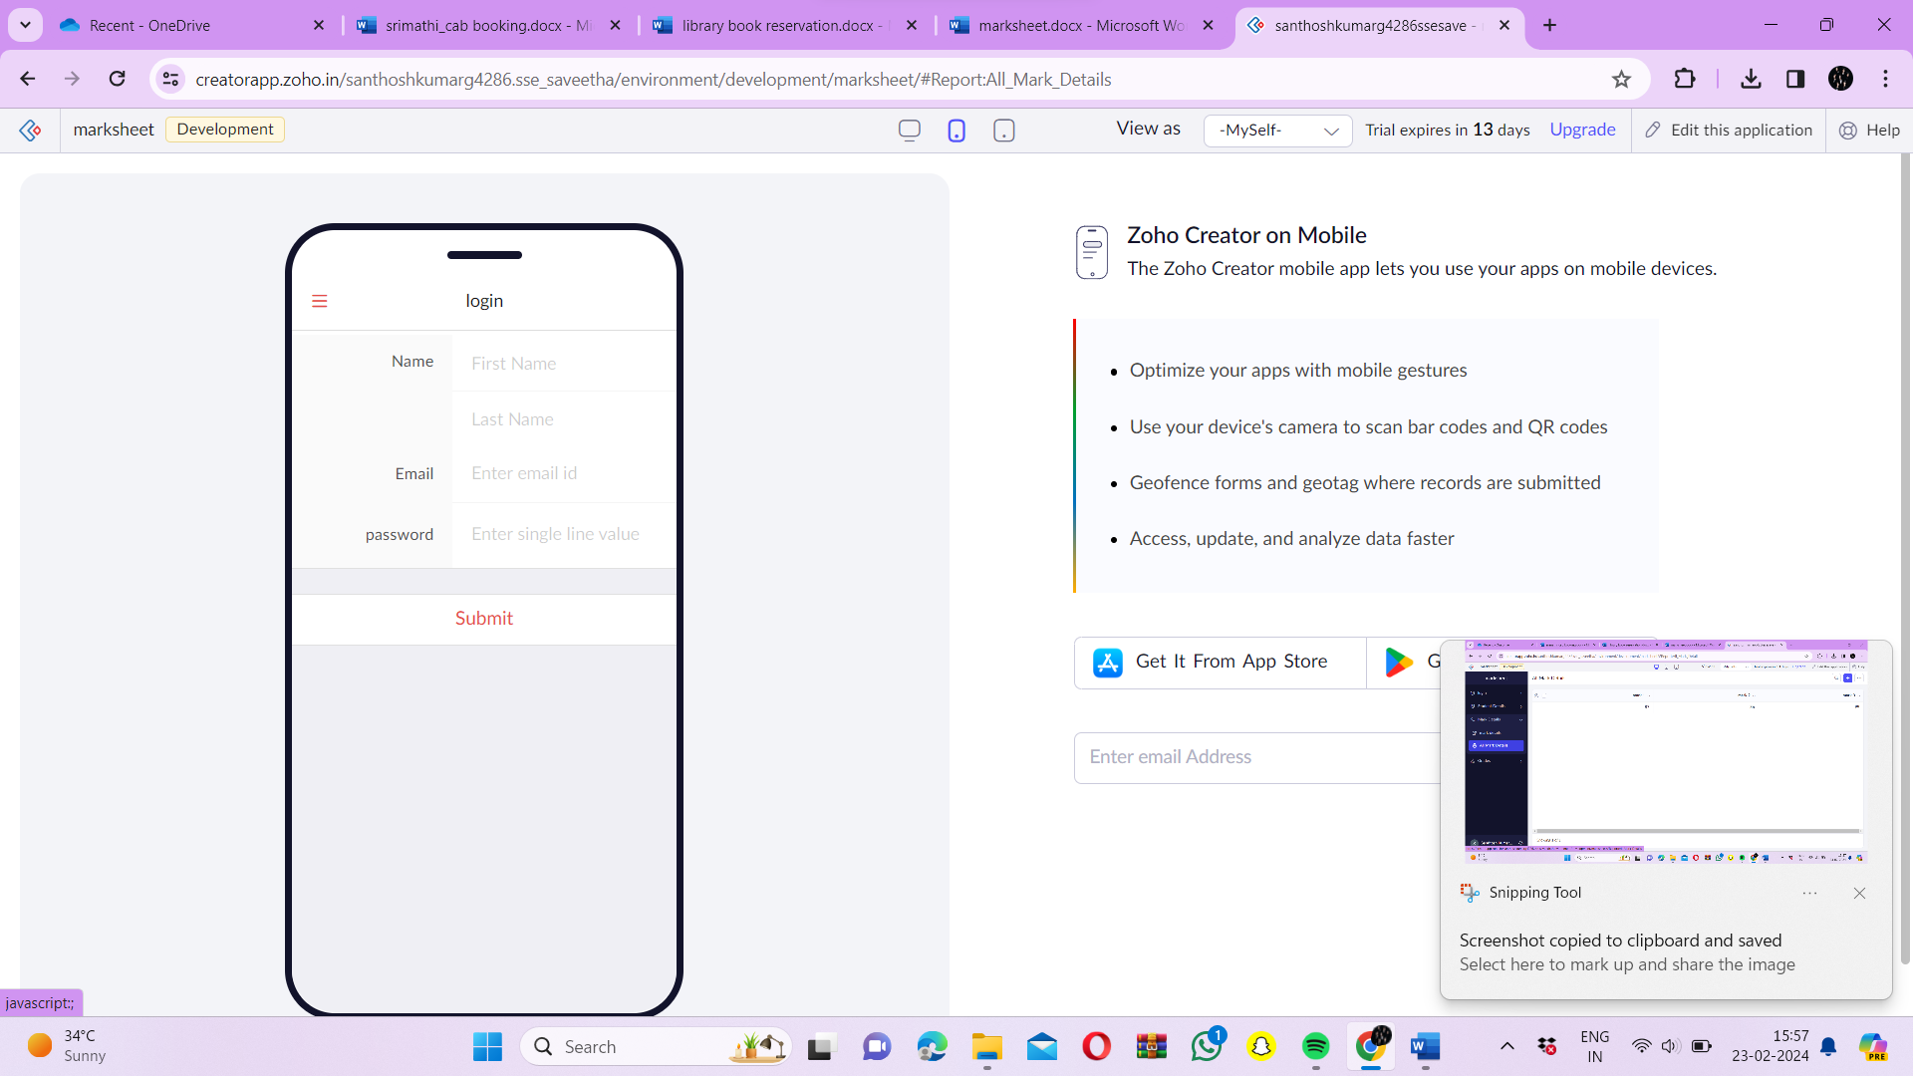

Step 11: - Click the tablet icon to view the output in tablet format

